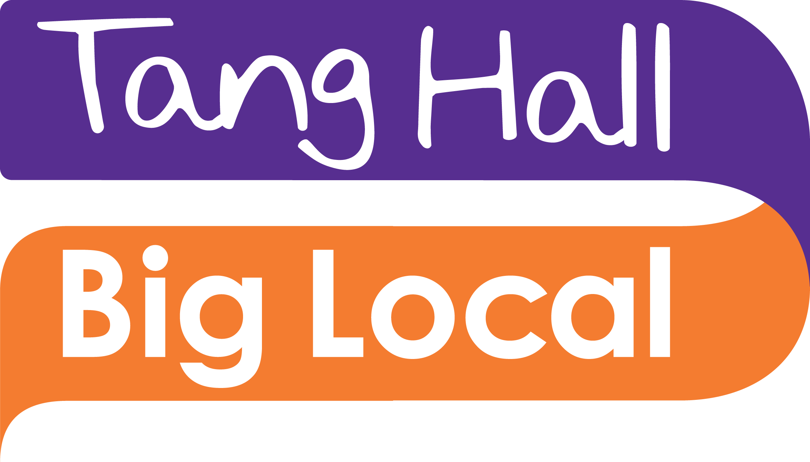

Tang Hall Big Local – Community Events and Volunteer Coordinator - The Person Specification

We’re looking for a dynamic communicator who’s passionate about making a difference. If you love bringing new ideas to the table and you’d like to kickstart your charity career with a small local charity with a big heart then we’d love to hear from you.

Please use this table to tell us about the skills, qualities and experience you have that are directly relevant to this role. Once you’ve completed the table, please email it to anna@thbl.org.uk along with a covering email and contact details for two referees. The closing date for applications is 5pm on Fri 25 November.

Essential: The following are the skills, qualities and experience which we believe are essential to the role.

What we’re looking for: | Your experience in this area:  (It helps us if you tell us where and when you gained this experience)
Proven experience of setting up and delivering community events and initiatives and working with volunteers.

Understanding of delivery of volunteer procedures and good practice including risk assessments and safeguarding.

Experience of working with a diverse groups of people and understanding their needs

Experience of developing and maintaining partnerships

Experience of managing budgets for volunteering activity in cost effective manner

A willingness to be flexible and adaptable to the requirements of the events and volunteers

Ability to inspire and motivate others

Have good organisational skills and being approachable

Confident using Microsoft Office 365 apps including Word, Excel and PowerPoint and working in an office environment and produce oral and written reports.

Desirable: The following would also be an advantage (but are not essential and we can provide training and support):

We’d love you to have: | Your experience, if any, in this area:  (It helps us if you tell us where and when you gained this experience)
Experience of promoting volunteering including the use of social media and offline marketing.

Experience of handling personal data – knowledge of GDPR and its regulatory procedures

Reporting and evaluating community events and activities

Experience of developing people through volunteer/membership programmes and sign posting to relevant organisations.

An understanding of the Voluntary sector and its commitment to collaboration and co-production, equal opportunities and inclusivity

Knowledge of Tang Hall Big Local and an understanding and commitment to its values

As this role will involve attending community events, it would be useful if you have a full and clean driving licence and access to a vehicle.

