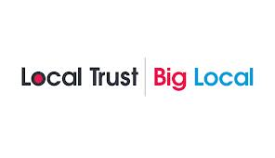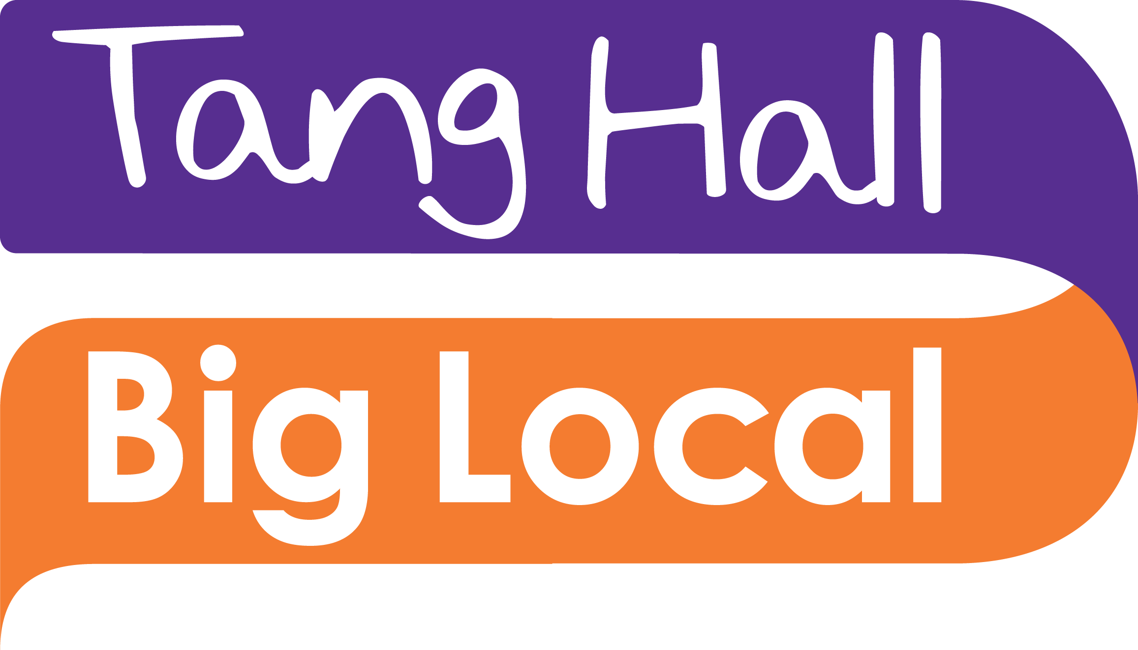

Community Events and Volunteer Coordinator for Tang Hall Big Local

Tang Hall in York is one of 150 areas in England chosen to deliver Big Local – a community- led, 10-year Big Lottery funded programme which helps residents create lasting change through an investment of at least £1 million.

Tang Hall Big Local puts residents and their community firmly in the driving seat enabling them to identify local needs, take action and make an impact. Tang Hall Big Local is all about delivering in partnership, making the best of local knowledge, skills, ambition and enthusiasm to make Tang Hall an even better place to live.

In 2022 Tang Hall Big Local, will be in year 7 of its 10-year plan with exciting commissions and activities in the pipeline, developing people and places within the Tang Hall community.

The Coordinator role is an important part of supporting the delivery of the plan working with the THBL Partnership, trustees, staff and volunteers supporting residents to get involved and working with partners in co-production and collaboration to ensure an inclusive and diverse approach.

Tang Hall Big Local is looking for a Volunteer Coordinator with community development skills, who can work in a busy office and support a variety of events and activities that bring the community together to achieve their goals.

Email; office@thbl.org.uk for an application form or visit www.thbl.org.uk
See FB Tang Hall Big Local Twitter @TangHBigLocal YouTube – Tang Hall Big Local

