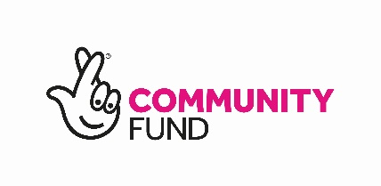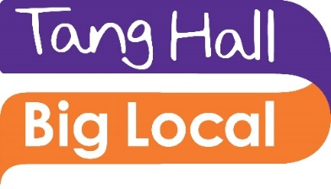
Tang Hall Big Local Community Grant Report Form
Within one month of the end of your project, please complete this form to explain what you did and how this benefited Tang Hall Big Local residents.
We would also be delighted to receive any additional information or evidence to provide that helps to show what your project has achieved, for example photographs, case studies, quotes from participants etc.
Please email to anna@thbl.org.uk

Organisation______________________________________________________
Name of person completing form_____________________________________
Phone__________________________Email_____________________________
Project start date___________________End date________________________

- How many people were involved in your project?
 | Total number? | Number of these who live in the Tang Hall Big Local area? | Number of those living in THBL area who were new to your work?
As participants/users of your project
As volunteers helping deliver the project

(To check whether someone lives in the Tang Hall Big Local area, see the THBL map. We can also provide a list of postcodes.)

- How did you go about publicising your project to local people? What method(s) did you find most effective?

- Describe briefly what you did – project activities

- What difference did your project make for the people involved? How do you know?

- What was the highlight of your project?

- Was there anything that didn’t go so well?

- What have you learnt through delivering the project?

- How did you go about promoting Tang Hall Big Local to your project participants?

- Please tell us about any feedback you may have received from participants about their experience of living in Tang Hall, or about Tang Hall Big Local.

- Money
Your project budget from your application |  | Actual
Expenditure (list the items from your original budget) | £ | £
Total expenditure
Income
Tang Hall Big Local grant
Other income
Total income
Income - expenditure
Balance of Tang Hall Big Local grant to claim

Note: In most cases we will have paid you 80% of your grant up front, and the final 20% will be released following receipt of this report.

- Any other comments about your project or this grants programme?

