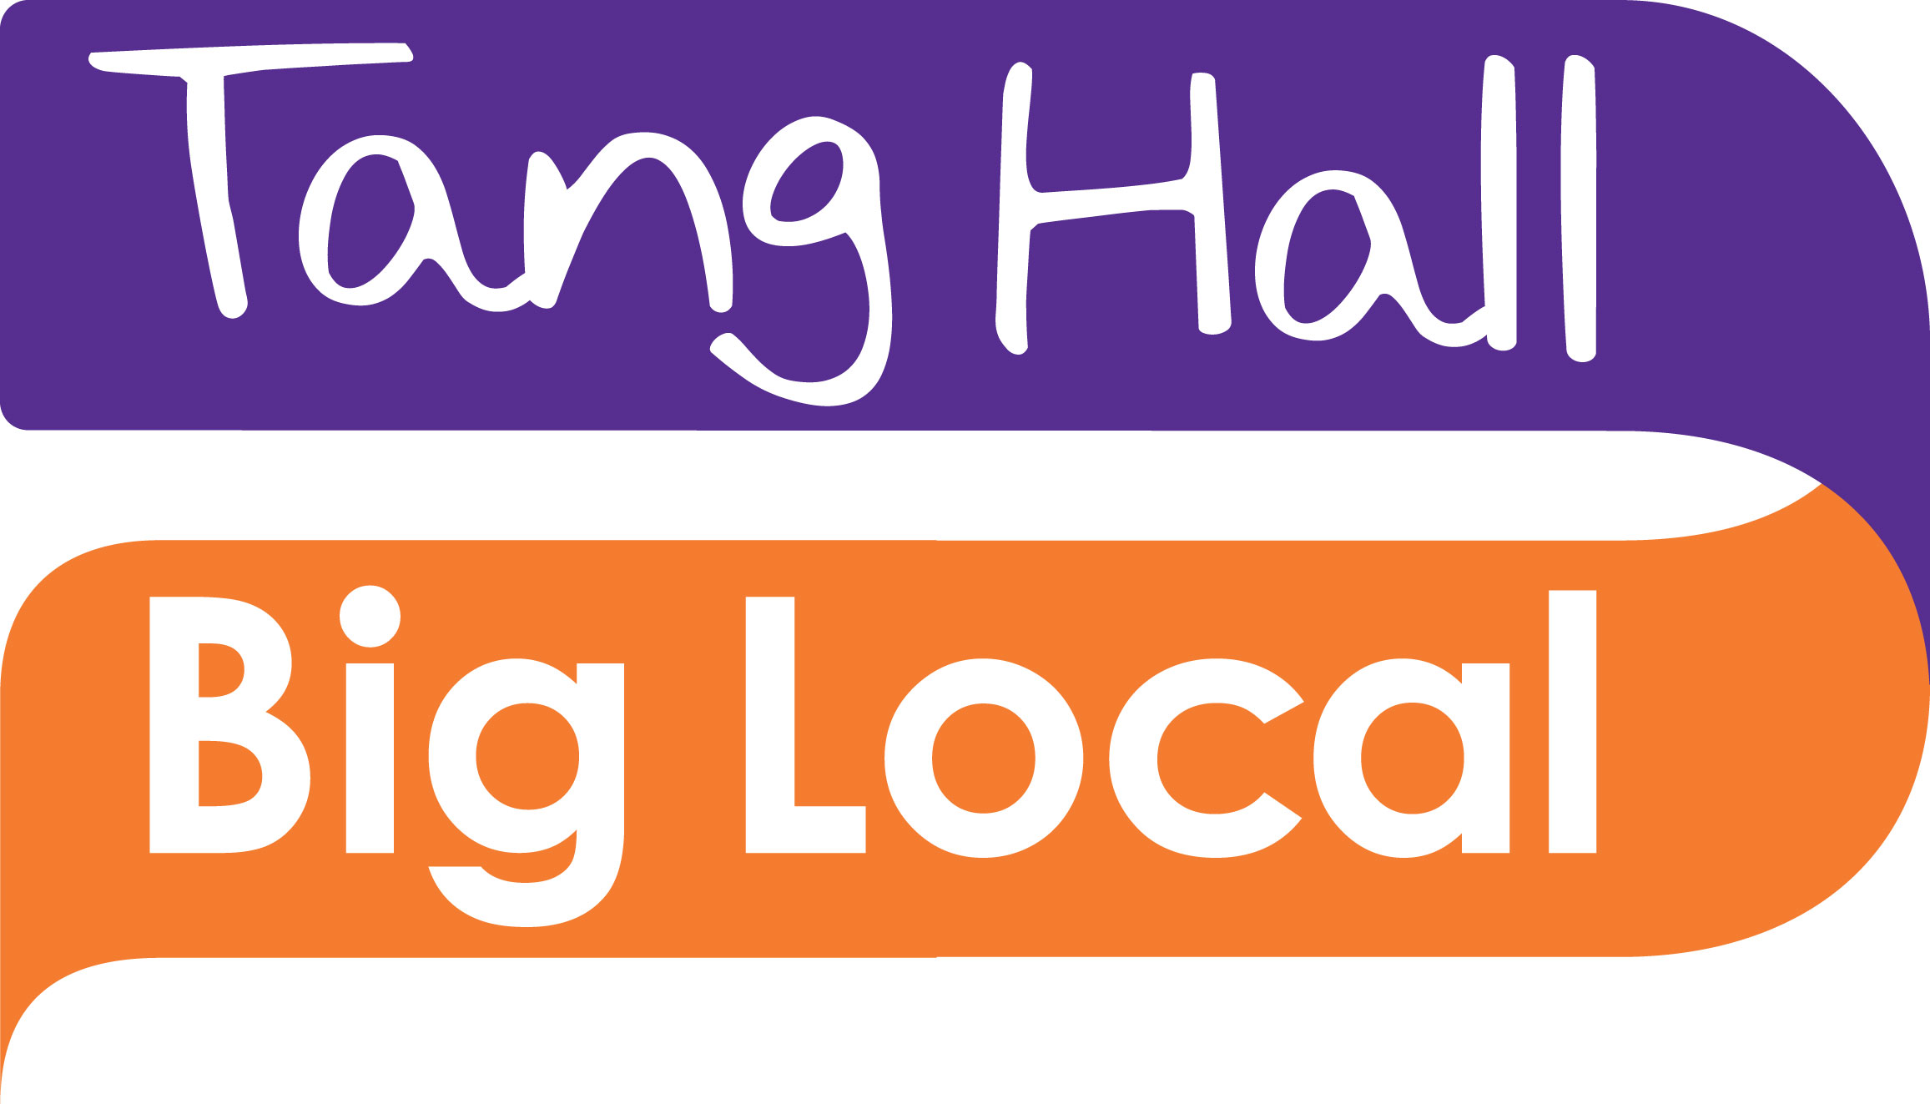

Information for the Administrator and Finance Role for Tang Hall Big Local (THBL)
The role will be part time: 22.5 hours per week. Hours can be flexible but there will be requirement to attend Partnership & CIO meetings which can be late afternoon or evening. Most hours will be worked at THBL office at Tang Hall Community Centre.
Reporting to: THBL Project Lead
Salary: £18,000-20,500 pro rata (based on experience)
The successful applicant will be required to have an enhanced DBS check under the Disclosure and Barring Service.

1. Introduction

The Big Lottery Fund is, through Local Trust and Big Local, investing at least £1m into the Tang Hall area in York to support a 10-year programme of activities to support local residents to make the area an even better place to live.

Tang Hall Big Local is about making Tang Hall an even better place to live and work. Local residents are working together to get local people who live and/or work in Tang Hall involved in planning how to use the £1 million awarded to the area.

The Partnership has been appointed by local residents and organisations as the people responsible for delivering the Local Plan. Working together with the Local Trust to ensure the fund is spent as agreed. Tang Hall Big Local CIO is a registered charity.

This is a unique opportunity for an individual with a vocation and passionate about community development/engagement work to alongside the Partnership, the THBL charity, working groups, other local residents and stakeholders to deliver the THBL Local Plan

2. The brief

Purpose

To oversee the delivery of overall project outputs set out in the Local Plan. This will involve working with key individuals and stakeholders, managing specific project areas and budgets, and taking a lead in developing and implementing the communications plan in order to raise awareness with, and engage all parts of the Tang Hall Big Local community in line with our objectives.

Main Tasks/Responsibilities
- Providing an administrative service to THBL Partnership & CIO meetings and working groups as agreed – setting meeting dates, drafting agendas with the Partnership Chair & Chair of CIO writing minutes, and following up actions as appropriate.
- Manage administrative systems and procedures, looking after THBL office and provide THBL with operating manual for office procedures
- Work closely with staff of service providers to provide login/password access points to software, subscriptions, website, social media and any other relevant material with regard to suppliers, IT and databases.
- Contribute to report writing.
- Provide office support for THBL office at TH Community Centre as required
- Provide regular progress updates to partnership & CIO
- Process payments, log financial information, produce finance reports for CIO and Partnership. Support the Project lead to submit Spend Reports to Local Trust
- Liaise with accountants & external examiners in preparation of year end accounts. Ensure the information for Annual Report to Charity Commission is submitted on time.
- Develop and maintain databases of contacts and partners.
- Overseeing procurement of goods and services by suppliers for THBL events, office and activities
- Co-ordinate marketing, publicity and communications for Tang Hall Big Local including posters, update and expand website content, e-communications.
- Provide event support for Tang Hall Big Local events and activities & attend events if required
- Administration of THBL Grant Scheme by advertising opportunities, receiving applications, responding to queries and receiving grant applicants reports.
- Develop and maintain databases of contacts and partners.
Specification

The selected individual will have the following evidenced experience, understanding, skills and competencies.

Essential: E,
Desirable: D
Experience
Managing a busy office | E
Servicing meetings | E
Effective teamworking | E
Diary management | E
Management of financial processes and systems | E
Collaborative working | E
Relationship building in a community context | D
Event support alongside volunteers | D
Cloud based data and file sharing systems e.g. G Suite, training will be given | D
Knowledge / Understanding
Knowledge of administrative and financial procedures | E
Knowledge of the Tang Hall area | D
Knowledge of the charitable sector and management of grants | D
Skills/competencies
Excellent and administrative skills – the ability to prepare and manage paperwork and procedures | E
The ability to get things done – managing own time and working to deadlines | E
Fully competent in MS Office software, in particular Word and Excel | E
Competent in ICT and online tools | E
Excellent communication skills – across an extensive variety of people and organisations and using verbal and written communication (including report writing, e mail and letter writing) | E
Commitment to equality and diversity in all work – able to establish activities and relationships that foster respectful and positive links across all ages, races, faiths and gender | E
Willingness to work flexibly, able to identify and adapt to new opportunities and challenges | D

Application and Selection

To apply for this work you should send:

- A full, up to date CV (to include details of 2 referees who we can contact for references on your employment/track record)
- A description (maximum 2 sides of A4) of the skills, experience, knowledge and competencies that you offer and how these meet the role purpose, tasks and responsibilities and role specification
- A covering letter with full contact details.

You should email this information to the Tang Hall Big Local Project Lead as follows: anna@thbl.org.uk

Closing date: Friday 3 May 2019

Interviews/selection

Interviews for shortlisted applicants will take place at the THBL Office in Tang Hall Community Centre.

Further any further information contact Anna, our Project Lead 07305 5803668.

Visit our website www.thbl.org.uk FB Tang Hall Big Local
Twitter @TangHBigLocal You Tube - Tang Hall Big Local and the Local Trust website

